1. Classification Techniques

Classification techniques in data mining are capable of processing a large amount of data. It can be used to predict categorical class labels and classifies data based on training set and class labels and it can be used for classifying newly available data.The term could cover any context in which some decision or forecast is made on the basis of presently available information. Classification procedureis recognized method for repeatedly making such decisions in new situations. Here if we assume that problem is a concern with the construction of a procedure that will be applied to a continuing sequence of cases in which each new case must be assigned to one of a set of pre defined classes on the basis of observed features of data.Creation of a classification procedure from a set of data for which the exact classes are known in advance is termed as pattern recognition or supervised learning. Contexts in which a classification task is fundamental include, for example, assigning individuals to credit status on the basis of financial and other personal information, and the initial diagnosis of a patient’s disease in order to select immediate treatment while awaiting perfect test results. Some of the most critical problems arising in science, industry and commerce can be called as classification or decision problems.Three main historical strands of research can be identified: statistical, machine learning andneural network. All groups have some objectives in common. They have all attempted to develop procedures that would be able to handle a wide variety of problems and to be extremely general used in practical settings with proven success.
Statistical Procedure Based Approach
Two main phases of work on classification can be identified within the statistical community. The first “classical” phase concentrated on extension of Fisher’s early work on linear discrimination. The second, “modern” phase concentrated on more flexible classes of models many of which attempt to provide an estimate of the joint distribution of the features within each class which can in turn provide a classification rule . Statistical procedures are generally characterised by having an precise fundamental probability model which provides a probability of being in each class instead of just a classification. Also it is usually assumed that the techniques will be used by statisticians and hence some human involvement is assumed with regard to variable selection and transformation and overall structuring of the problem.
Machine Learning Based Approach
Machine Learning is generally covers automatic computing procedures based on logical or binary operations that learn a task from a series of examples. Here we are just concentrating on classification and so attention has focussed on decision-tree approaches in which classification results from a sequence of logical steps. These classification results are capable of representing the most complex problem given sufficient data. Other techniques such as genetic algorithms and inductive logic procedures (ILP) are currently under active improvement and its principle would allow us to deal with more general types of data including cases where the number and type of attributes may vary. Machine Learning approach aims to generate classifying expressions simple enough to be understood easily by the human and must mimic human reasoning sufficiently to provide insight into the decision process .Like statistical approaches background knowledge may be used in development but operation is assumed without human interference.
Neural Network
The field of Neural Networks has arisen from diverse sources ranging from understanding and emulating the human brain to broader issues of copying human abilities such as speech and can be use in various fields such as banking, legal, medical, news, in classification program to categorise data as intrusive or normal. Generally neural networks consist of layers of interconnected nodes where each node producing a non-linear function of its input and input to a node may come from other nodes or directly from the input data. Also, some nodes are identified with the output of the network.
On the basis of this example there are different applications for neural networks that involve recognizing patterns and making simple decisions about them. In airplanes we can use a neural network as a basic autopilot where input units reads signals from the various cockpit instruments and output units modifying the plane’s controls appropriately to keep it safely on course. Inside a factory we can use a neural network for quality control.
Classifications Algorithms
Classification is one of the Data Mining techniques that is mainly used to analyze a given data set and takes each instance of it and assigns this instance to a particular class such that classification error will be least. It is used to extract models that accurately define important data classes within the given data set. Classification is a two step process. During first step the model is created by applying classification algorithm on training data set then in second step the extracted model is tested against a predefined test data set to measure the model trained performance and accuracy. So classification is the process to assign class label from data set whose class label is unknown.
ID3 Algorithm
Id3 calculation starts with the original set as the root hub. On every cycle of the algorithm it emphasizes
through every unused attribute of the set and figures the entropy (or data pick up IG(A)) of that attribute. At that point chooses the attribute which has the smallest entropy (or biggest data gain) value. The set is S then split by the selected attribute (e.g. marks < 50, marks < 100, marks >= 100) to produce subsets of the information. The algorithm proceeds to recurse on each and every item in subset and considering only items never selected before. Recursion on a subset may bring to a halt in one of these cases:
- Every element in the subset belongs to the same class (+ or -), then the node is turned into a leaf and
labelled with the class of the examples
- If there are no more attributes to be selected but the examples still do not belong to the same class (some are + and some are -) then the node is turned into a leaf and labelled with the most common class of the examples in that subset.
- If there are no examples in the subset, then this happens when parent set found to be matching a specific value of the selected attribute. For example if there was no example matching with marks >=100 then a leaf is created and is labelled with the most common class of the examples in the parent set.
Working steps of algorithm is as follows,
- Calculate the entropy for each attribute using the data set S.
- Split the set S into subsets using the attribute for which entropy is minimum (or, equivalently, information gain is maximum)
- Construct a decision tree node containing that attribute in a dataset.
- Recurse on each member of subsets using remaining attributes.

C4.5 Algorithm
C4.5 is an algorithm used to produce a decision tree which is an expansion of prior ID3 calculation. It enhances the ID3 algorithm by managing both continuous and discrete properties, missing values and pruning trees after construction. The decision trees created by C4.5 can be used for grouping and often referred to as a statistical classifier. C4.5 creats decision trees from a set of training data same way as Id3 algorithm. As it is a supervised learning algorithm it requires a set of training examples which can be seen as a pair: input object and a desired output value (class). The algorithm analyzes the training set and builds a classifier that must have the capacity to accurately arrange both training and test cases. A test example is an input object and the algorithm must predict an output value. Consider the sample training data set S=S₁,S₂,…Sn which is already classified. Each sample S_{i} consist of feature vector (x₁,_{i}, x_{2,i}, …, x_{n,i}) where x_{j} represent attributes or features of the sample and the class in which S_{i} falls.At each node of the tree C4.5 selects one attribute of the data that most efficiently splits its set of samples into subsets such that it results in one class or the other. The splitting condition is the normalized information gain (difference in entropy) which is a non-symmetric measure of the difference between two probability distributions P and Q. The attribute with the highest information gain is chosen to make the decision. General working steps of algorithm is as follows,
- Assume all the samples in the list belong to the same class. If it is true, it simply creates a leaf node for the decision tree so that particular class will be selected.
- None of the features provide any information gain. If it is true, C4.5 creates a decision node higher up the tree using the expected value of the class.
- Instance of previously-unseen class encountered. Then, C4.5 creates a decision node higher up the tree using the expected value.
C. K Nearest Neighbors Algorithm
The closest neighbor (NN) rule distinguishes the classification of unknown data point on the basis of its closest neighbor whose class is already known. M. Cover and P. E. Hart purpose k nearest neighbour (KNN) in which nearest neighbor is computed on the basis of estimation of k that indicates how many nearest neighbors are to be considered to characterize class of a sample data point. It makes utilization of the more than one closest neighbor to determine the class in which the given data point belongs to and and consequently it is called as KNN. These data samples are needed to be in the memory at the run time and hence they are referred to as memory-based technique. T. Bailey and A. K. Jain enhance KNN which is focused on weights. The training points are assigned weights according to their distances from sample data point. But at the same time the computational complexity and memory requirements remain the primary concern dependably. To overcome memory limitation size of data set is reduced. For this the repeated patterns which don’t include additional data are also eliminated from training data set. To further enhance the information focuses which don’t influence the result are additionally eliminated from training data set. The NN training data set can be organized utilizing different systems to enhance over memory limit of KNN. The KNN implementation can be done using ball tree, k-d tree, nearest feature line (NFL), principal axis search tree and orthogonal search tree. The tree structured training data is further divided into nodes and techniques like NFL and tunable metric divide the training data set according to planes. Using these algorithms we can expand the speed of basic KNN algorithm. Consider that an object is sampled with a set of different attributes. Assuming its group can be determined from its attributes; different algorithms can be used to automate the classification process. In pseudo code k-nearest neighbor classification algorithm can be expressed,
K ← number of nearest neighbors
For each object Xin the test set do
calculate the distance D(X,Y) between X and every object Y in the training set
neighborhood ← the k neighbors in the training set closest to X
X.class ← SelectClass (neighborhood)
End for
Naïve Bayes Algorithm
The Naive Bayes Classifier technique is based on Bayesian theorem and is particularly used when the dimensionality of the inputs is high. The Bayesian Classifier is capable of calculating the most possible output based on the input. It is also possible to add new raw data at runtime and have a better probabilistic classifier. A naive Bayes classifier considers that the presence (or absence) of a particular feature(attribute) of a class is unrelated to the presence (or absence) of any other feature when the class variable is given. For example, a fruit may be considered to be an apple if it is red, round. Even if these features depend on each other or upon the existence of other features of a class, a naive Bayes classifier considers all of these properties to independently contribute to the probability that this fruit is an apple. Algorithm works as follows,
Bayes theorem provides a way of calculating the posterior probability, P(c|x), from P(c), P(x), and P(x|c). Naive Bayes classifier considers that the effect of the value of a predictor (x) on a given class (c) is independent of the values of other predictors.

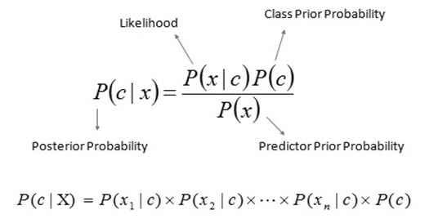

- P(c|x) is the posterior probability of class (target) given predictor (attribute) of class.
- P(c) is called the prior probability of class.
- P(x|c) is the likelihood which is the probability of predictor of given class.
- P(x) is the prior probability of predictor of class.

SVM Algorithm
SVM have attracted a great deal of attention in the last decade and actively applied to various domains applications. SVMs are typically used for learning classification, regression or ranking function. SVM are based on statistical learning theory and structural risk minimization principal and have the aim of determining the location of decision boundaries also known as hyperplane that produce the optimal separation of classes [1][2][3].Maximizing the margin and thereby creating the largest possible distance between the separating hyperplane and the instances on either side of it has been proven to reduce an upper bound on the expected generalization error [8]. Efficiency of SVM based classification is not directly depend on the dimension of classified entities. Though SVM is the most robust and accurate classification technique, there are several problems. The data analysis in SVM is based on convex quadratic programming, and it is computationally expensive, as solving quadratic programming methods require large matrix operations as well as time consuming numerical computations [4]. Training time for SVM scales quadratically in the number of examples, so researches strive all the time for more efficient training algorithm[5], resulting in several variant based algorithm.
SVM can also be extended to learn non-linear decision functions by first projecting the input data onto a high-dimensional feature space using kernel functions and formulating a linear classification problem in that feature space [4]. The resulting feature space is much larger than the size of dataset which are not possible to store in popular computers. Investigation on this issues leads to several decomposition based algorithms. The basic idea of decomposition method is to split the variables into two parts: set of free variables called as working set, which can be updated in each iteration and set of fixed variables, which are fixed at a particular value temporarily. This procedure is repeated until the termination conditions are met
[5]. Originally, the SVM was developed for binary classification, and it is not simple to extend it for multi-class classification problem. The basic idea to apply multi classification to SVM is to decompose the multi class problems into several two class problems that can be addressed directly using several SVMs [6].
ANN Algorithm
Artificial neural networks (ANNs) are types of computer architecture inspired by biological neural networks (Nervous systems of the brain) and are used to approximate functions that can depend on a large number of inputs and are generally unknown. Artificial neural networks are presented as systems of interconnected “neurons” which can compute values from inputs and are capable of machine learning as well as pattern recognition due their adaptive nature.
An artificial neural network operates by creating connections between many different processing elements each corresponding to a single neuron in a biological brain. These neurons may be actually constructed or simulated by a digital computer system. Each neuron takes many input signals then based on an internal weighting produces a single output signal that is sent as input to another neuron. The neurons are strongly interconnected and organized into different layers. The input layer receives the input and the output layer produces the final output. In general one or more hidden layers are sandwiched in between the two. This structure makes it impossible to forecast or know the exact flow of data.
Artificial neural networks typically start out with randomized weights for all their neurons. This means that initially they must be trained to solve the particular problem for which they are proposed. A back-propagation ANN is trained by humans to perform specific tasks. During the training period, we can evaluate whether the ANN’s output is correct by observing pattern. If it’s correct the neural weightings that produced that output are reinforced; if the output is incorrect, those weightings responsible can be diminished.
Implemented on a single computer, an artificial neural network is normally slower than more traditional solutions of algorithms. The ANN’s parallel nature allows it to be built using multiple processors giving it a great speed advantage at very little development cost. The parallel architecture allows ANNs to process very large amounts of data very efficiently in less time. When dealing with large continuous streams of information such as speech recognition or machine sensor data ANNs can operate considerably faster as compare to other algorithms. An artificial neural network is useful in a variety of real-world applications such as visual pattern recognition and speech recognition that deal with complex often incomplete data. In addition, recent programs for text-to-speech have utilized ANNs. Many handwriting analysis programs (such as those used in popular PDAs) are currently using ANNs.
Advantages and Disadvantages of Classification Algorithm

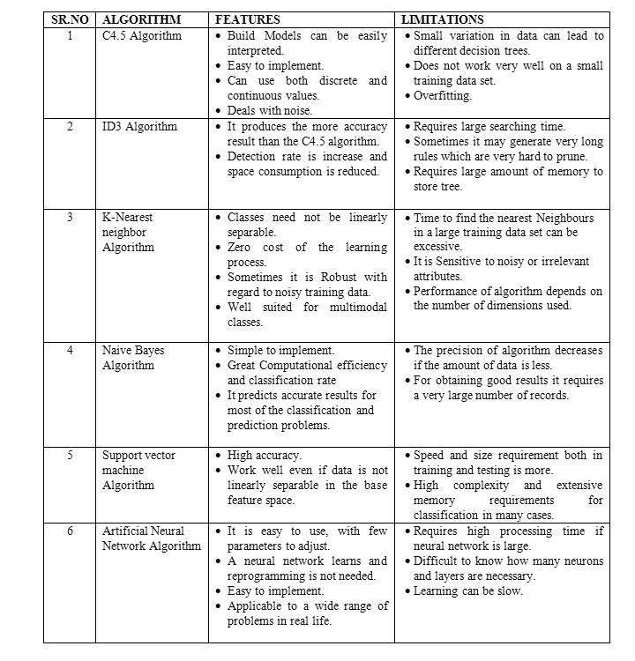

2. Regression Techniques,
1. Simple Linear Regression model: Simple linear regression is a statistical method that enables users to summarise and study relationships between two continuous (quantitative) variables. Linear regression is a linear model wherein a model that assumes a linear relationship between the input variables (x) and the single output variable (y). Here the y can be calculated from a linear combination of the input variables (x). When there is a single input variable (x), the method is called a simple linear regression. When there are multiple input variables, the procedure is referred as multiple linear regression.
Application: some of the most popular applications of Linear regression algorithm are in financial portfolio prediction, salary forecasting, real estate predictions and in traffic in arriving at ETAs.
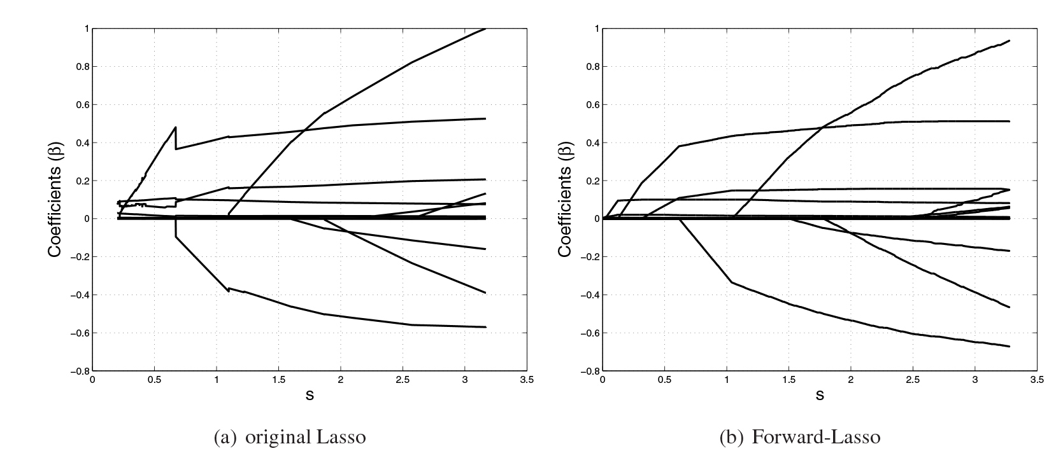
2. Lasso Regression: LASSO stands for Least Absolute Selection Shrinkage Operator wherein shrinkage is defined as a constraint on parameters. The goal of lasso regression is to obtain the subset of predictors that minimize prediction error for a quantitative response variable. The algorithm operates by imposing a constraint on the model parameters that causes regression coefficients for some variables to shrink toward a zero.
Variables with a regression coefficient equal to zero after the shrinkage process are excluded from the model. Variables with non-zero regression coefficients variables are most strongly associated with the response variable. Explanatory variables can be either quantitative, categorical or both. This lasso regression analysis is basically a shrinkage and variable selection method and it helps analysts to determine which of the predictors are most important.
Application: Lasso regression algorithms have been widely used in financial networks and economics. In finance, its application is seen in forecasting probabilities of default and Lasso-based forecasting models are used in assessing enterprise wide risk framework. Lasso-type regressions are also used to perform stress test platforms to analyze multiple stress scenarios.
3. Logistic regression: One of the most commonly used regression techniques in the industry which is extensively applied across fraud detection, credit card scoring and clinical trials, wherever the response is binary has a major advantage. One of the major upsides is of this popular algorithm is that one can include more than one dependent variable which can be continuous or dichotomous. The other major advantage of this supervised machine learning algorithm is that it provides a quantified value to measure the strength of association according to the rest of variables. Despite its popularity, researchers have drawn out its limitations, citing a lack of robust technique and also a great model dependency.
Application: Today enterprises deploy Logistic Regression to predict house values in real estate business, customer lifetime value in the insurance sector and are leveraged to produce a continuous outcome such as whether a customer can buy/will buy scenario.
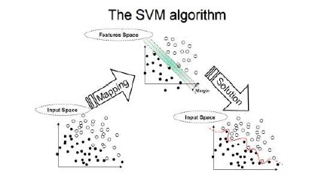
4. Support Vector Machines: Support Vector Machine (SVM) is another most powerful algorithm with strong theoretical foundations based on the Vapnik-Chervonenkis theory, as defined by Oracle docs. This supervised machine learning algorithm has strong regularization and can be leveraged both for classification or regression challenges. They are characterized by usage of kernels, the sparseness of the solution and the capacity control gained by acting on the margin, or on number of support vectors, etc. The capacity of the system is controlled by parameters that do not depend on the dimensionality of feature space. Since the SVM algorithm operates natively on numeric attributes, it uses a z-score normalization on numeric attributes. In regression, Support Vector Machines algorithms use epsilon-insensitivity (margin of tolerance) loss function to solve regression problems.
Application: support vector machines regression algorithms has found several applications in the oil and gas industry, classification of images and text and hypertext categorization. In the oilfields, it is specifically leveraged for exploration to understand the position of layers of rocks and create 2D and 3D models as a representation of the subsoil.
5. Multivariate Regression algorithm: This technique is used when there is more than one predictor variable in a multivariate regression model and the model is called a multivariate multiple regression. Termed as one of the simplest supervised machine learning algorithms by researchers, this regression algorithm is used to predict the response variable for a set of explanatory variables. This regression technique can be implemented efficiently with the help of matrix operations and in Python, it can be implemented via the “numpy” library which contains definitions and operations for matrix object.
Application: Industry application of Multivariate Regression algorithm is seen heavily in the retail sector where customers make a choice on a number of variables such as brand, price and product. The multivariate analysis helps decision makers to find the best combination of factors to increase footfalls in the store.
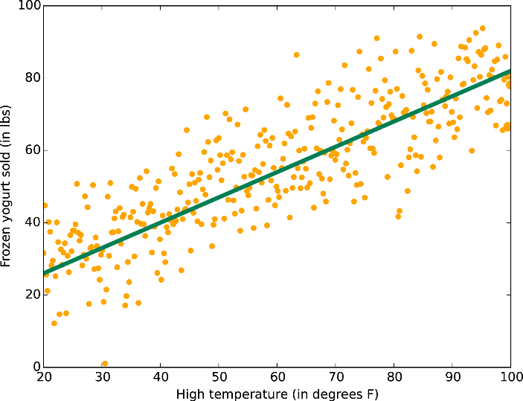
6. Multiple Regression Algorithm: This regression algorithm has several applications across the industry for product pricing, real estate pricing, marketing departments to find out the impact of campaigns. Unlike linear regression technique, multiple regression, is a broader class of regressions that encompasses linear and nonlinear regressions with multiple explanatory variables.
Application: Some of the business applications of multiple regression algorithm in the industry are in social science research, behavioural analysis and even in the insurance industry to determine claim worthiness.

3. Scalability and data management issues in data mining algorithms

Data mining is not an easy task, as the algorithms used can get very complex and data is not always available at one place. It needs to be integrated from various heterogeneous data sources. These factors also create some issues. Here in this tutorial, we will discuss the major issues regarding −
- Mining Methodology and User Interaction
- Performance Issues
- Diverse Data Types Issues
The following diagram describes the major issues.
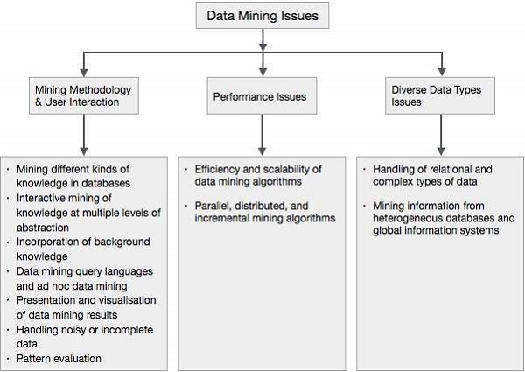

Mining Methodology and User Interaction Issues
It refers to the following kinds of issues −
- Mining different kinds of knowledge in databases − Different users may be interested in different kinds of knowledge. Therefore it is necessary for data mining to cover a broad range of knowledge discovery task.
- Interactive mining of knowledge at multiple levels of abstraction− The data mining process needs to be interactive because it allows users to focus the search for patterns, providing and refining data mining requests based on the returned results.
- Incorporation of background knowledge − To guide discovery process and to express the discovered patterns, the background knowledge can be used. Background knowledge may be used to express the discovered patterns not only in concise terms but at multiple levels of abstraction.
- Data mining query languages and ad hoc data mining − Data Mining Query language that allows the user to describe ad hoc mining tasks, should be integrated with a data warehouse query language and optimized for efficient and flexible data mining.
- Presentation and visualization of data mining results − Once the patterns are discovered it needs to be expressed in high level languages, and visual representations. These representations should be easily understandable.
- Handling noisy or incomplete data − The data cleaning methods are required to handle the noise and incomplete objects while mining the data regularities. If the data cleaning methods are not there then the accuracy of the discovered patterns will be poor.
- Pattern evaluation − The patterns discovered should be interesting because either they represent common knowledge or lack novelty.

Performance Issues
There can be performance-related issues such as follows −
- Efficiency and scalability of data mining algorithms − In order to effectively extract the information from huge amount of data in databases, data mining algorithm must be efficient and scalable.
- Parallel, distributed, and incremental mining algorithms − The factors such as huge size of databases, wide distribution of data, and complexity of data mining methods motivate the development of parallel and distributed data mining algorithms. These algorithms divide the data into partitions which is further processed in a parallel fashion. Then the results from the partitions is merged. The incremental algorithms, update databases without mining the data again from scratch.

Diverse Data Types Issues
- Handling of relational and complex types of data − The database may contain complex data objects, multimedia data objects, spatial data, temporal data etc. It is not possible for one system to mine all these kind of data.
- Mining information from heterogeneous databases and global information systems − The data is available at different data sources on LAN or WAN. These data source may be structured, semi structured or unstructured. Therefore mining the knowledge from them adds challenges to data mining.

Data Mining
Data mining is defined as extracting the information from a huge set of data. In other words we can say that data mining is mining the knowledge from data. This information can be used for any of the following applications −
- Market Analysis
- Fraud Detection
- Customer Retention
- Production Control
- Science Exploration

Data Mining Engine
Data mining engine is very essential to the data mining system. It consists of a set of functional modules that perform the following functions −
- Characterization
- Association and Correlation Analysis
- Classification
- Prediction
- Cluster analysis
- Outlier analysis
- Evolution analysis

Knowledge Base
This is the domain knowledge. This knowledge is used to guide the search or evaluate the interestingness of the resulting patterns.

Knowledge Discovery
Some people treat data mining same as knowledge discovery, while others view data mining as an essential step in the process of knowledge discovery. Here is the list of steps involved in the knowledge discovery process −
- Data Cleaning
- Data Integration
- Data Selection
- Data Transformation
- Data Mining
- Pattern Evaluation
- Knowledge Presentation

User interface
User interface is the module of data mining system that helps the communication between users and the data mining system. User Interface allows the following functionalities −
- Interact with the system by specifying a data mining query task.
- Providing information to help focus the search.
- Mining based on the intermediate data mining results.
- Browse database and data warehouse schemas or data structures.
- Evaluate mined patterns.
- Visualize the patterns in different forms.

Data Integration
Data Integration is a data preprocessing technique that merges the data from multiple heterogeneous data sources into a coherent data store. Data integration may involve inconsistent data and therefore needs data cleaning.

Data Cleaning
Data cleaning is a technique that is applied to remove the noisy data and correct the inconsistencies in data. Data cleaning involves transformations to correct the wrong data. Data cleaning is performed as a data preprocessing step while preparing the data for a data warehouse.

Data Selection
Data Selection is the process where data relevant to the analysis task are retrieved from the database. Sometimes data transformation and consolidation are performed before the data selection process.

Clusters
Cluster refers to a group of similar kind of objects. Cluster analysis refers to forming group of objects that are very similar to each other but are highly different from the objects in other clusters.

Data Transformation
In this step, data is transformed or consolidated into forms appropriate for mining, by performing summary or aggregation operations.

4. Measures of Interestingness

Kindly visit:
https://www.researchgate.net/publication/220566216_Interestingness_Measures_for_Data_Mining_A_Survey

